79. If Else Condition and Lightning Tables - 29 July 2022

1] If-Else Condition

2] Simple HTML Table

3] Data Table

1] If-Else Condition

Syntax:

IF:

<aura:if isTrue="{!v.truthy}">

True

</aura:if>

**IF ELSE**

**<aura:if isTrue="{!v.truthy}">**

**True**

**<aura:set attribute="else">**

**False**

**</aura:set>**

**</aura:if>**

<aura:component controller="ApplicantProvider" implements="force:appHostable,flexipage:availableForAllPageTypes,flexipage:availableForRecordHome,force:hasRecordId,forceCommunity:availableForAllPageTypes,force:lightningQuickAction" access="global" >

<aura:attribute name="applicantObject" type="Applicant__c" default="{'sObjectType' : 'Applicant__c'}" />

<aura:attribute name="showDetailsFlag" type="Boolean" default="false" />

<lightning:card>

<lightning:input type="text" name="appName" label="Enter Applicant ID" required="true" value="{!v.applicantObject.Name}"/> <br/>

<lightning:button variant="brand" iconName="utility:search" label="Search" title="Search" onclick="{!c.searchApplicantController}" /> <br/>

<aura:if isTrue="{!v.showDetailsFlag}">

First Name = {!v.applicantObject.First_Name__c} <br/>

Last Name = {!v.applicantObject.Last_Name__c} <br />

Gender = {!v.applicantObject.Gender__c} <br/>

Police Verification = {!v.applicantObject.Police_Verification__c}

</aura:if>

</lightning:card>

</aura:component>

JS CONTROLLER:

({

searchApplicantController : function(component, event, helper) {

helper.searchApplicantHelper(component, event, helper);

}

})

JS HELPER:

({

searchApplicantHelper : function(component, event, helper) {

var action = component.get('c.searchApplicantRecord'); //1

action.setParams({'objApp' : component.get('v.applicantObject')});

$A.enqueueAction(action);

action.setCallback(this, function(response){

var state = response.getState();

if(state === 'SUCCESS'){

console.log('sucess '+ JSON.stringify(response.getReturnValue()));

component.set('v.applicantObject' , response.getReturnValue());

component.set('v.showDetailsFlag', true);

}

else{

console.log('error ');

component.set('v.showDetailsFlag', false);

}

});

}

})

1] Simple HTML Table

Lightning Simple Table:

<table class="slds-table slds-table--bordered slds-table--striped">



<thead>

<tr>



<th scope="col"><span class="slds-truncate" >Field Name1 </span></th>

<th scope="col"><span class="slds-truncate">Field Name 2</span></th>



</tr>



</thead>

<tbody>

<tr>

<td> Value </td>

<td> Value </td>



</tr>

</tbody>

</table>



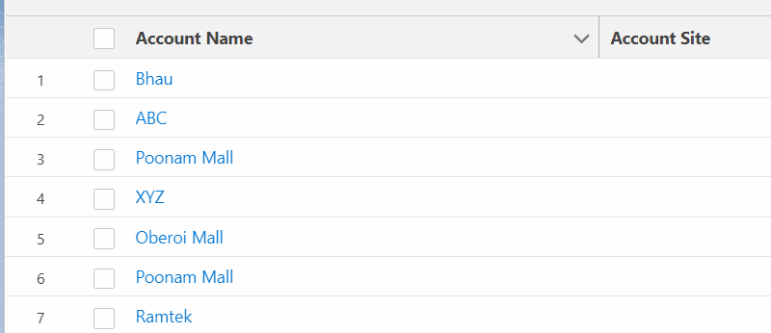

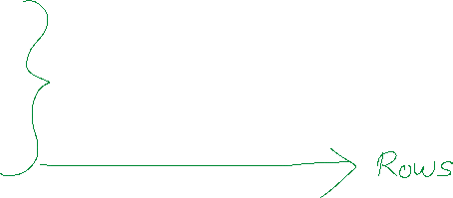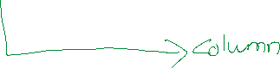

User Story 1] Search Applicant ID and show information in a table.

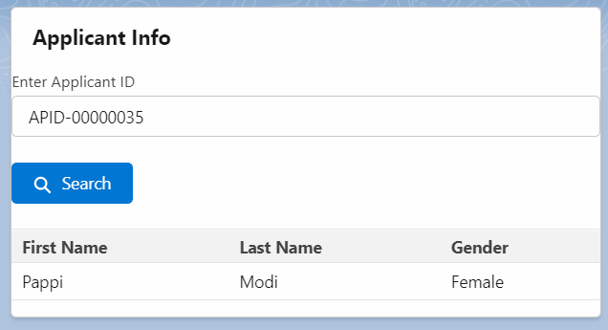

COMPONENT:

<aura:component controller="ApplicantProvider" implements="force:appHostable,flexipage:availableForAllPageTypes,flexipage:availableForRecordHome,force:hasRecordId,forceCommunity:availableForAllPageTypes,force:lightningQuickAction" access="global" >

<aura:attribute name="applicantObject" type="Applicant__c" default="{'sObjectType' : 'Applicant__c'}" />

<aura:attribute name="showDetailsFlag" type="Boolean" default="false" />

<lightning:card>

<lightning:input type="text" name="appName" label="Enter Applicant ID" required="true" value="{!v.applicantObject.Name}"/> <br/>

<lightning:button variant="brand" iconName="utility:search" label="Search" title="Search" onclick="{!c.searchApplicantController}" /> <br/>

<aura:if isTrue="{!v.showDetailsFlag}">

<table class="slds-table slds-table--bordered slds-table--striped">

<thead>

<tr>

<th scope="col"><span class="slds-truncate" >Applicant ID</span></th>

<th scope="col"><span class="slds-truncate">First Name</span></th>

<th scope="col"><span class="slds-truncate">Last Name</span></th>

<th scope="col"><span class="slds-truncate">Gender</span></th>

</tr>

</thead>

<tbody>

<tr>

<td> <ui:outputText value="{!v.applicantObject.Name}"/> </td>

<td> <ui:outputText value="{!v.applicantObject.First_Name__c}" /> </td>

<td> {!v.applicantObject.Last_Name__c} </td>

<td> {!v.applicantObject.Gender__c} </td>

</tr>

</tbody>

</table>

</aura:if>

</lightning:card>

</aura:component>

3] Data Table

Syntax:

Component:

DATA TABLE WILL REQUIRE A LIST:

<lightning:datatable

keyField="id"

data="{! v.data }"

columns="{! v.columns }"

hideCheckboxColumn="true"/>

JS Controller:

component.set('v.columns', [

{label: 'Opportunity name', fieldName: 'opportunityName', type: 'text'},

{label: 'Account name', fieldName: 'accountName', type: 'text'}

]);

COMPONENT:

<aura:component controller="ApplicantProvider" implements="force:appHostable,flexipage:availableForAllPageTypes,flexipage:availableForRecordHome,force:hasRecordId,forceCommunity:availableForAllPageTypes,force:lightningQuickAction" access="global" >

<aura:attribute name="applicantObject" type="Applicant__c" default="{'sObjectType' : 'Applicant__c'}" />

<aura:attribute name="showDetailsFlag" type="Boolean" default="false" />

<aura:attribute name="accList" type="List" />

<aura:attribute name="columns" type="List" />

<lightning:card>

<lightning:input type="text" name="appName" label="Enter Applicant ID" required="true" value="{!v.applicantObject.Name}"/> <br/>

<lightning:button variant="brand" iconName="utility:search" label="Search" title="Search" onclick="{!c.searchApplicantController}" /> <br/>

<aura:if isTrue="{!v.showDetailsFlag}">

<lightning:datatable

keyField="id"

data="{! v.accList }"

columns="{! v.columns }"

hideCheckboxColumn="false"/>

</aura:if>

</lightning:card>

</aura:component>

JS CONTROLLER:

({

searchApplicantController : function(component, event, helper) {

component.set('v.columns', [

{label: 'Applicant ID', fieldName: 'Name', type: 'text'},

{label: 'First Name', fieldName: 'First_Name__c', type: 'text'},

{label: 'Last Name', fieldName: 'Last_Name__c', type: 'text'},

{label: 'Gender', fieldName: 'Gender__c', type: 'text'}

]);

helper.searchApplicantHelper(component, event, helper);

}

})

JS HELPER:

({

searchApplicantHelper : function(component, event, helper) {

var action = component.get('c.searchApplicantRecord'); //1

action.setParams({'objApp' : component.get('v.applicantObject')});

$A.enqueueAction(action);

action.setCallback(this, function(response){

var state = response.getState();

if(state === 'SUCCESS'){

console.log('sucess '+ JSON.stringify(response.getReturnValue()));

component.set('v.accList' , response.getReturnValue());

component.set('v.showDetailsFlag', true);

}

else{

console.log('error ');

component.set('v.showDetailsFlag', false);

}

});

}

})

ASSINGNMENT:

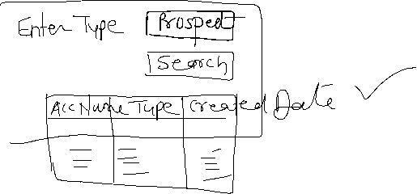

**2]**

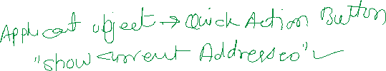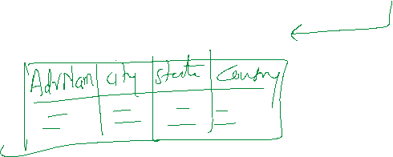

HINT : JS HELPER

Action.setParams({“applicantID” : component.get(‘v.recordId’) });

Apex Code:

Public static List<Address__c> Method(ID applicantId){

}